Sierra Leone Civil War
From Wikipedia, the free encyclopedia

The Sierra Leone Civil War (1991–2002) began on 23 March 1991 when the Revolutionary United Front (RUF) intervened in Sierra Leone in an attempt to overthrow the Joseph Momoh government. The resulting civil war lasted 11 years, enveloped the country, and left over 50,000 dead.^{[7]}

During the first year of the war, the RUF took control of territory in eastern and southern Sierra Leone, which were rich in alluvial diamonds. The government's ineffective response to the RUF, and the disruption in government diamond production, precipitated a military coup d'état in April 1992 by the National Provisional Ruling Council (NPRC).^{[8]} By the end of 1993, the Sierra Leone Army (SLA) had succeeded in pushing the RUF rebels back to the Liberian border, but the RUF recovered and fighting continued. Sierra Leone installed an elected civilian government in March 1996, but hostilities recommenced.^{[9][10]}

In May 1997 a group of disgruntled SLA officers staged a coup and established the Armed Forces Revolutionary Council (AFRC) as the new government of Sierra Leone.^{[11]} The RUF joined with the AFRC to capture Freetown with little resistance. The new government, led by Johnny Paul Koroma, declared the war over. A wave of looting, rape, and murder followed the announcement.^{[12]} Reflecting international dismay at the overturning of the civilian government, ECOMOG (The Economic Community of Western African States Monitoring Group) forces intervened and retook Freetown on behalf of the government, but they found the outlying regions more difficult to pacify.

In January 1999, world leaders intervened diplomatically to promote negotiations between the RUF and the government.^{[13]} The Lome Peace Accord, signed on 27 March 1999, was the result. Lome gave Foday Sankoh, the commander of the RUF, the vice presidency and control of Sierra Leone's diamond mines in return for a cessation of the fighting and the deployment of a UN peacekeeping force to monitor the disarmament process. RUF compliance with the disarmament process was inconsistent and sluggish, and by May 2000, the rebels were advancing again upon Freetown.^{[14]} As the UN mission began to fail the United Kingdom declared its intention to intervene in the former colony and Commonwealth member in an attempt to support the weak government of President Ahmad Tejan Kabbah. With help from a renewed UN mandate and Guinean air support, the British Operation Palliser finally defeated the RUF, taking control of Freetown. On 18 January 2002, President Kabbah declared the Sierra Leone Civil War over.

War atrocities and Crimes against humanity

During the Sierra Leone Civil War numerous atrocities were committed including war rape, mutilation, and mass murder, causing many of the perpetrators to be tried in international criminal courts, and the establishment of a truth and reconciliation commission. A 2001 overview noted that there had been “serious and grotesque human rights violations” in Sierra Leone since its civil war began in 1991.The rebels, the Revolutionary United Front (RUF), had “committed horrendous abuses.”

Mass killings of civilians: At least 50,000 to possibly as many as 300,000^{[7]} died during the conflict and only 30,000^{[100][2]}soldiers from all sides are estimated to have participated, meaning at least 20,000 civilians were killed. The most notorious example of this was the 1999 Freetown massacre. This took place in January 1999 when the AFRC/RUF set upon Freetown in a bloody assault known as "Operation No Living Thing" in which rebels entered neighborhoods to loot, rape and kill indiscriminately.^{[105]} A Human Rights Watch report documented the atrocities committed during this attack. The report estimated that over 7,000 people were killed and that at least half of them were civilians.^{[106]} Reports from survivors describe perverse brutality including incinerating people alive while locked in their houses, hacking civilians' hands and other limbs off with machetes.^{[107]}

Drafting of Underage Soldiers: About one quarter of the soldiers serving in the government armed forces during the civil war were under age 18.^{[98]} “Recruitment methods were brutal – sometimes children were abducted, sometimes they were forced to kill members of their own families so as to make them outcasts, sometimes they were drugged, sometimes they were forced into conscription by threatening family members.” Child soldiers were deliberately overwhelmed with violence “in order to completely desensitize them and make them mindless killing machines.”^{[108]}

Mass War Rape- During the Sierra Leone Civil War gender specific violence was widespread. Rape, sexual slavery and forced marriages were commonplace during the conflict.^{[109]} The majority of assaults were carried out by the Revolutionary United Front (RUF). The Armed Forces Revolutionary Council (AFRC), The Civil Defence Forces (CDF), and the Sierra Leone Army (SLA) have also been implicated in sexual violence. The RUF, even though they had access to women, who had been abducted for use as either sex slaves or combatants, frequently raped non-combatants.^{[110]} The militia also carved the RUF initials into women's bodies, which placed them at risk of being mistaken for enemy combatants if they were captured by government forces.^{[111]} Women who were in the RUF were expected to provide sexual services to the male members of the militia. And of all women interviewed, only two had not been repeatedly subjected to sexual violence; gang rape and individual rapes were commonplace.^{[112]} A report from PHR stated that the RUF was guilty of 93 per cent of sexual assaults during the conflict.^{[113]} The RUF was notorious for human rights violations, and regularly amputated arms and legs from their victims.^{[114]}

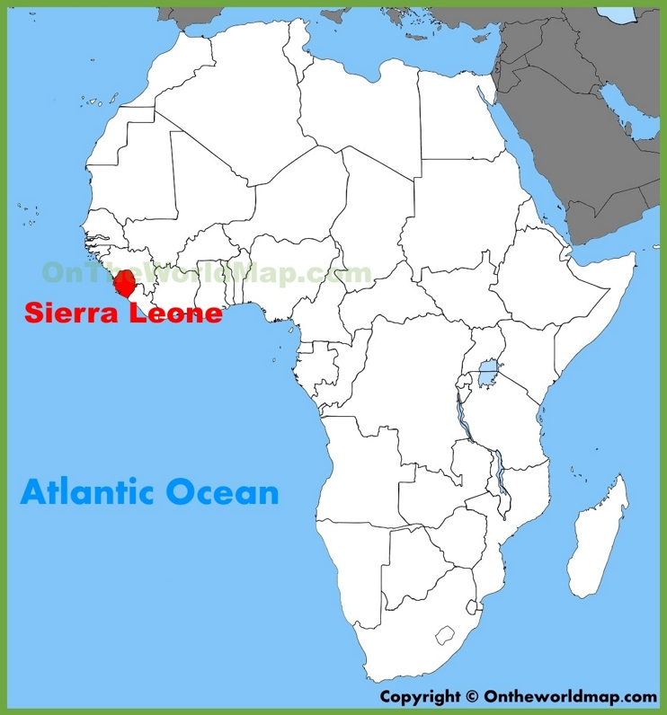
QUESTIONS
1. Who is Joseph Manoh?
2. Who/what is the RUF?
3. What happened on March 27, 1999?
4. How many civilians died in the war?
5. What happened in Freetown in January 1999?
6. Why were child soldiers overwhelmed with violence?

